PARENT TOPIC INFORMATION – YEAR 5 – AUTUMN TERM 2

These are the topics & areas of the curriculum which the pupils will be covering in November and December in Year 5

Literacy
Reading
- Pupils are encouraged to read independently at home using a combination of their own choice of reading & reading set by the class teacher.
- To consider character behaviour & actions, identifying & discussing the key issues dealt with in text.
- To be able to identify & summarise evidence from text to support a hypothesis.
- To explore texts to gain understanding. Know how to clarify words & ideas.
- To carry out factual research. Scan texts to locate key words, phrases, useful headings & key sentences. (Nonfiction)
- To identify how & why paragraphs within nonfiction texts are used to organise & sequence information.
- Recount – BIOGRAPHY – Explore the topic of Superheroes & develop a subject specific vocabulary. Know what a Biography is, how information is gathered to complete a biography & how to organise information to write a biography.
- To answer oral & written questions based on fiction & nonfiction texts.
- Make predictions from a picture & be able to support answer.
- To independently use time to check work & make necessary changes to improve work.
Writing
- To use notes to structure BIOGRAPHY.
- Comprehension Tasks – Know how to proof read work & make necessary changes. Answer questions including all relevant detail.
- To respond to a range of comprehension questions based on a character & setting.
Grammar & Punctuation
- Accurate use of capital letters, full stops, question marks, exclamation marks & commas in all writing.
- Understanding & use of nouns, verbs, adjectives & adverbs.
- How to use simple speech in written work.

Numeracy
Number
- Explore, count, read, write numbers within 10,000.
- Approximate numbers within 10 000 to the nearest 10, 100 or 1000.
- Extending addition & subtraction beyond 10 000.
- Problem Solving to include choosing & using appropriate operations & efficient calculation strategies, explaining methods of calculation of numbers orally & written.
- Revising addition & subtraction as inverse operations.
- Using the correct notation of money. + & - of shopping bills. Estimating costs by rounding up or down.
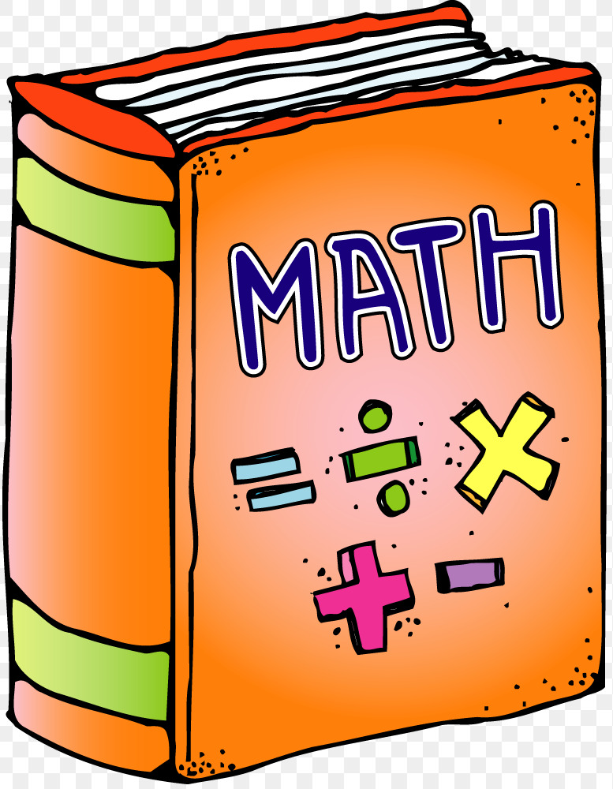
- Recognising the link between X & ÷ , link to everyday problem solving.
- Revision of X facts particularly X3, X6 & X9. Multiplying 3-digit numbers by a single digit with remainders.
- Division – revision of ÷ facts – quick recall. Extend ÷ any 3- or 4-digit number by a single number.
- Exploring multiplication patterns on 100 square.
- Looking at fractions of whole shapes / sets of objects – ½ ¼, fifths
- Extending & promoting the development of mathematical language.

*SECURE KNOWLEDGE OF NUMBER FACTS VERY IMPORTANT
Measures
- Sorting objects using Venn, Carroll & Tree Diagrams.
- Drawing & labelling pictograms.
Shape & Space
- Labelling 2D shapes & describing properties – square, rectangle, triangle, circle, hexagon, pentagon, semi-circle.
- Exploring tessellation.
- Right angles extending to acute, obtuse, straight & reflex angles.
Handling Data
- Reading & interpreting calendars.
- Units of time – minute/hour, hour/day, day/week/fortnight, month/year (Children need lots of support with this area)
- Telling the time – minutes past the hour on the analogue clock, quarter to the hour

World Around Us – TOPIC - SUPERHEROES
- To know what is meant by the term Superpower.
- How extreme weather affects the lives of people & animals in N.Ireland & further afield. How long- or short-term climatic changes are impacting on our environment.
- Changes brought about to a community by a natural disaster. Roles of various agencies in response to extreme weather or natural disasters.
- The safe use of electricity & dangers associated with electricity. Investigating simple circuits & discussing outcomes.
- Differences between renewable & non-renewable energy sources.

Anti-Bullying Week – Week Beginning 13 November 2023
‘Daily Mile Santa Run’ – Friday 1 December 2023
School Open Afternoon – Wednesday 13 December 2023
Charity Christmas Jumper Day – Friday 15 December 2023
Finish for Christmas – Thursday 21 December 2023 @ 12:15pm
Return to School – Thursday 4 January 2024
PLEASE KEEP CHECKING DOJO FOR UPDATES

