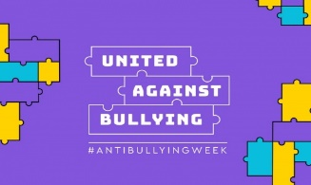
STRANDTOWN PRIMARY SCHOOL
NORTH ROAD, BELFAST, BT4 3DJ

12 November 2020

Dear Parent

Our school is taking part in Anti-Bullying Week this term between Monday 16 and Friday 20 November 2020. Anti-Bullying Week helps schools across the UK to shine a spotlight on bullying and encourage all children, teachers and parents to take action against bullying throughout the year.

The theme this year is “United Against Bullying”. The Anti-Bullying Alliance state on their website, “This year, more than ever, we’ve witnessed the positive power that society can have when we come together to tackle a common challenge. Anti-Bullying Week is no different. Bullying has a long lasting effect on those who experience and witness it. But by channelling our collective power, through shared efforts and shared ambitions, we can reduce bullying together. From parents and carers, to teachers and politicians, to children and young people, we all have a part to play in coming together to make a difference. We’re all a piece in the puzzle, and together, we’re united against bullying.”
During this week pupils will experience different learning activities within their own class bubbles. Pupils will learn about the true definition of bullying as well as focusing on the positive aspects of their own behaviour and character and the benefits to our school and society. On Monday 16th November we are going to have an “Odd Socks Day” when pupils will be able to join in various online activities with CBBC presenter, Andy Day.

What can you do to support us to stop bullying and participate in Anti-Bullying Week?
- Read the Anti-Bullying top tips for parents on the other side of this letter. Talk to your child about bullying and Anti-Bullying Week.
- The Anti-Bullying Alliance have a free online tool to support parents to understand bullying and what to do it you’re worried about it – you can access it at https://www.anti-bullyingalliance.org.uk/tools-information/advice-parents
- Come and talk to us! We want to hear from you what is working well, and what we could do differently to help stop bullying.
- To find out more information please refer to our own school Anti-Bullying policy which can be found on our school website.

Regards,
Mrs V Hutchinson, Principal
Mr R Ewart, Deputy Vice Principal and PDMU Co-ordinator
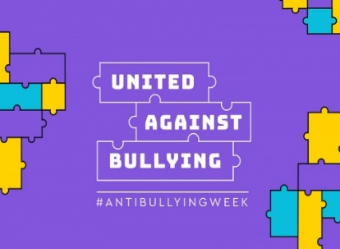
Anti Bullying Week 2020
Top anti-bullying tips

Tips for parents and carers

If your child is being bullied or you think they might be, here are some tips on how to talk to them and prevent further bullying.

- Talk to your child to understand their experiences. For it to be bullying it must be deliberate, intentional and repeated. Some actions may just be bad behaviour.
- If your child is being bullied, don’t panic. Explain to your child that the bullying is not their fault and together you will sort this out.
- Bullying is never acceptable; and should always be taken seriously. It is never your child’s fault it they’ve been bullied.
- Try and establish the facts. It can be helpful to keep a diary of events. If the bullying is online, save or copy images and text.
- Find out what your child wants to happen. Help to identify steps you can take; and the skills they have to help sort out the situation. Make sure you always keep them informed about any actions you decide to take.
- You may be tempted to tell your child to retaliate but this can have unpredictable results. Your child might get into trouble or get even more hurt. Rather – role play non-violent ways they can respond to children that are bullying them (e.g. “I don’t like it when you say that to me / do that to me. Stop.”); show them how to block or unfriend people if the bullying is online and help them identify other friends or adults that can support them.
- Encourage your child to get involved in activities that build their confidence and esteem, and help them to form friendships outside of school (or wherever the bullying is taking place).

Get some advice
There are many organisations that can give you some advice. Contact them if you are worried about bullying and want to talk to someone.
https://www.anti-bullyingalliance.org.uk/tools-information/advice-parents
You can access free anti-bullying online information at
https://www.anti-bullyingalliance.org.uk/tools-information/advice-parents/sources-information-advice-and-support

