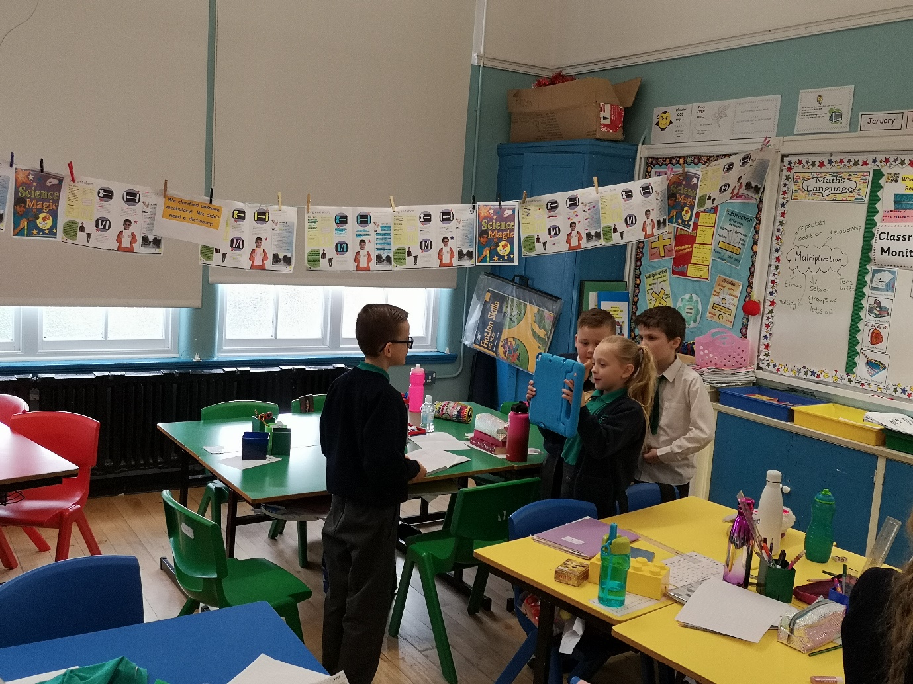

WE HOT SEATED FAIRY-TALE CHARACTERS AND ASKED INFERENCE QUESTIONS!

