School Council Mascot Competition.
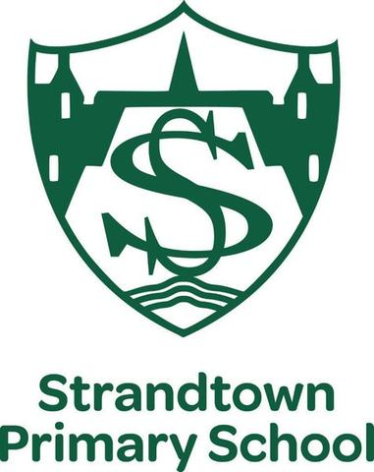
- In the summer term, we will have two NEW school buildings to move into.
- We, the school council, would like to have a NEW school mascot that could attend many different school events.
- It is our intention, with the help of the PTA to get the winning design made into a costume that can be worn in coming years.
RULES
- Each design must be submitted on either A4/A3 paper.
- You can choose which ever media you wish to represent your ideas on paper.
- Please clearly include a NAME for your mascot.
- Please write your name and room number on the back of your design.
- A gold token (50 House points) will be awarded to the winning entry from each class.
- The closing dates for entries is Wednesday 10th April, 2019. School councillors will collect the entries on that day.
Who will be Strandtown’s answer to Sparky?
Strandtown pupils …get designing!
