World Book Day 7th March 2019
“School Council Book Swap Day”

Have you books at home that you no longer read?

- Rather than just letting them sit and gather dust - bring them into school and swap with other pupils in your class so you can enjoy new books that you haven’t read before! (Each pupil may bring 2/3 books, if they wish)

- On World Book Day, pupils will have the opportunity to swap their old books for new books that they haven’t read before.

- If there are any books that pupils don’t wish to bring home again, these can be donated to the teacher’s class library.
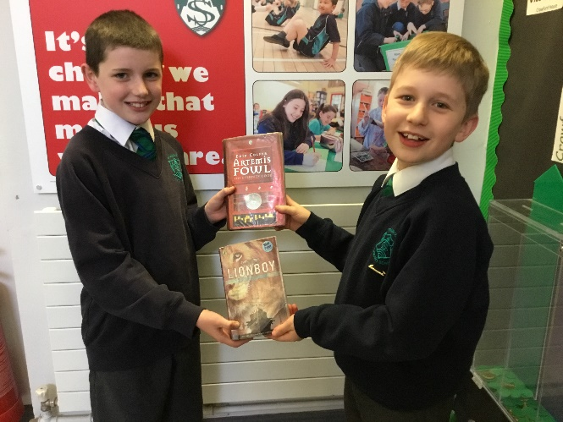
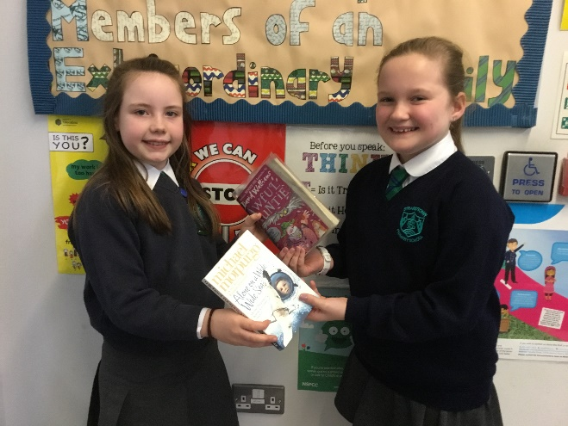
*Please ensure that all books brought into school are appropriate in content and are in a good condition. Please ask permission from an adult at home before bringing your books in.*

