Eco Club
‘make a change and let it grow’
The Eco Club visited Sandown Woods in Clarawood Estate on Tuesday 20th June - one of the final activities of 2016-17.
We met with Peter and Colin, 2 volunteers from the Woodland Trust, who chatted to us about the wood and gave us scavenger hunts and trails to complete. We enjoyed sharing our picnics and walking home along the Nature Walk.
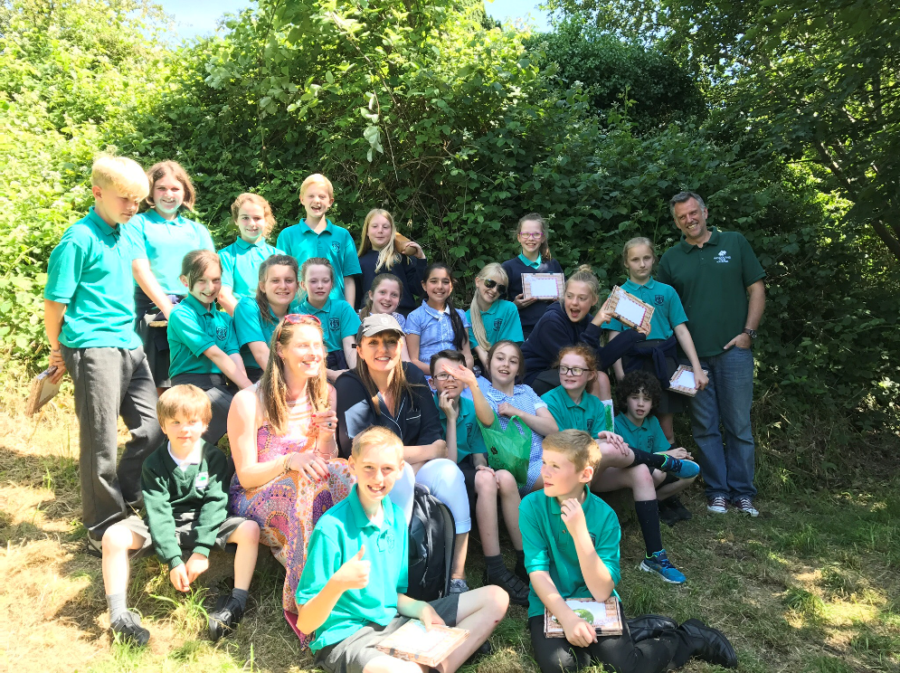
Colin invited us back to help with a project in the wood in Autumn, even the children who will then be in Year 8!

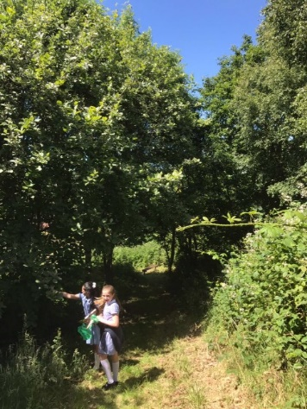
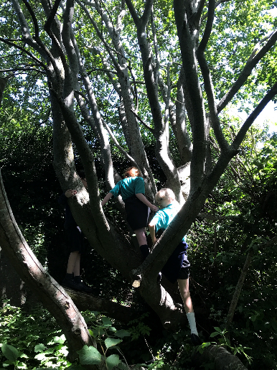
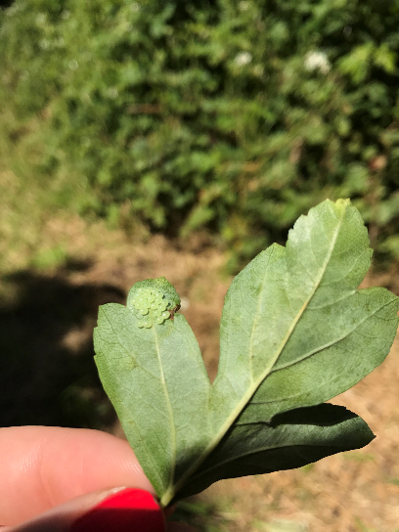
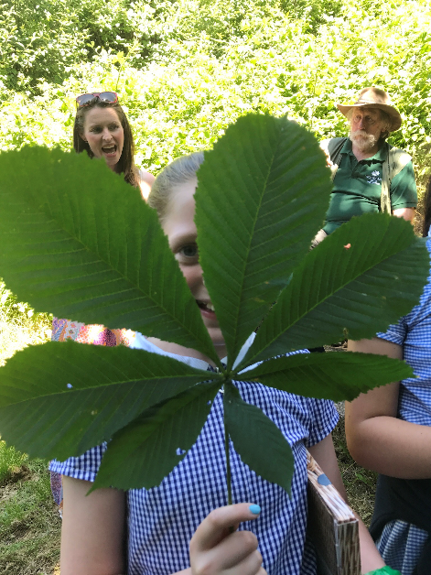
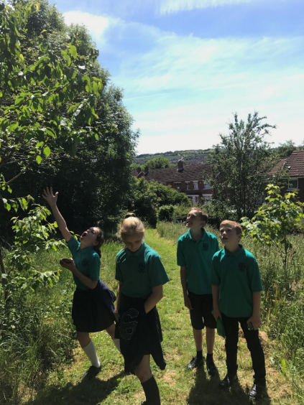

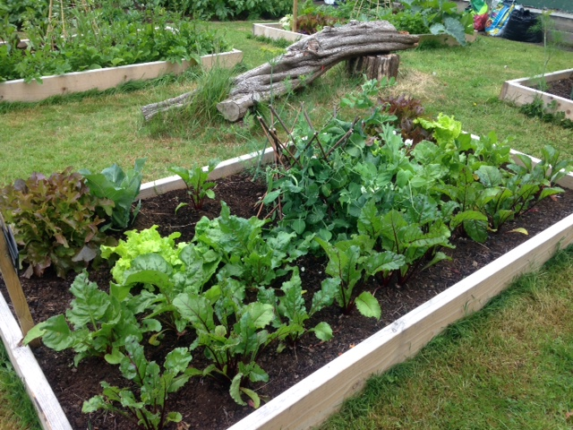
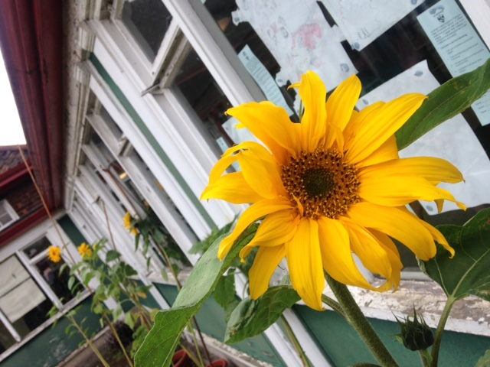
Take a look around our school garden, in June...

